Title: Cybersecurity & Data Privacy – Final Assignment (PortSwigger + Booking System Project)
Student: Md Mohaimenul Islam
Date: 21.12.2025

PortSwigger
Proof (Screenshot)
Screenshot: PortSwigger Dashboard showing completed labs (18 solved).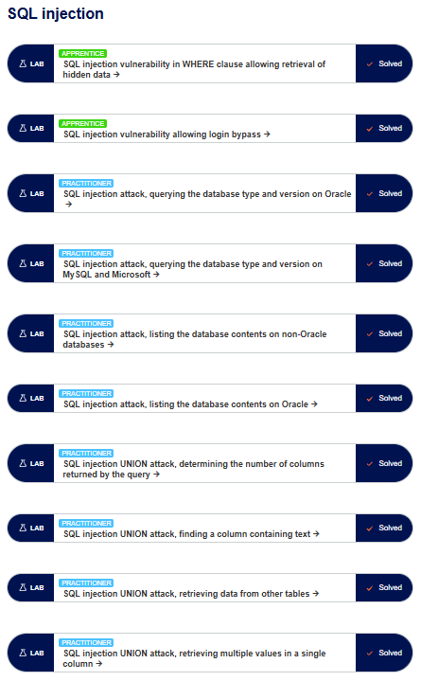
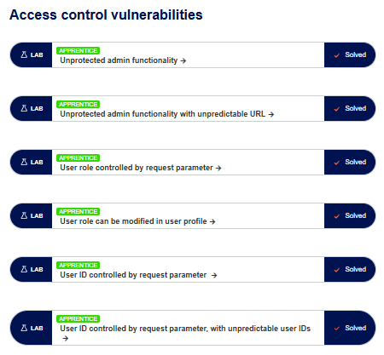

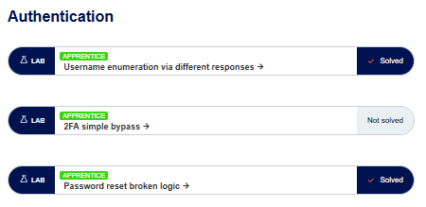
Completed labs list (18 total)
SQL injection (10)
- SQL injection vulnerability in WHERE clause allowing retrieval of hidden data
- SQL injection vulnerability allowing login bypass
- SQL injection attack, querying the database type and version on Oracle
- SQL injection attack, querying the database type and version on MySQL and Microsoft
- SQL injection attack, listing the database contents on non-Oracle databases
- SQL injection attack, listing the database contents on Oracle
- SQL injection UNION attack, determining the number of columns returned by the query
- SQL injection UNION attack, finding a column containing text
- SQL injection UNION attack, retrieving data from other tables
- SQL injection UNION attack, retrieving multiple values in a single column
Access control vulnerabilities (6)
- Unprotected admin functionality
- Unprotected admin functionality with unpredictable URL
- User role controlled by request parameter
- User role can be modified in user profile
- User ID controlled by request parameter
- User ID controlled by request parameter, with unpredictable user IDs
Authentication (2)
- Username enumeration via different responses
- Password reset broken logic

The Booking system project
Phase 1 → Part 1 (Initial testing + ZAP)
What I did:
- Deployed Phase 1 (part 1) using Docker Compose.
- Performed browser-based functionality tests (registration, login, resource, reservation, logout).
- Ran OWASP ZAP baseline/active scan and created report (round 1).
- Stored screenshots and reports in GitHub.
What worked: deployment + core pages opened successfully, ZAP scan produced findings.
What didn’t work / issues: some features behaved differently than expected and required re-checking paths/endpoints.
Most time spent on: understanding the workflow + correct testing steps + documenting results.
What I learned: how to run repeatable tests, record results, and create structured reports.
Repo:
Phase_1_→_Part_1 = https://github.com/Mimman10/progress/tree/main/Phase_1_%E2%86%92_Part_1

Phase 1 → Part 2 (Repeat tests + ZAP round 2)
What I did:
- Deployed Phase 1 part 2.
- Repeated the same functionality tests again and compared behavior.
- Ran ZAP again and exported zap_report_round2.md.
- Updated Git repo structure with screenshots + reports.
What worked: environment deployed, tests repeated, ZAP report generated.
What didn’t work / issues: some flows needed careful step-by-step verification because UI and actual behavior can differ.
Most time spent on: repeating tests properly + writing clean documentation.
What I learned: importance of consistent test cases and evidence (screenshots + notes).
Repo:
Phase_1_→_Part_2 = https://github.com/Mimman10/progress/tree/main/Phase_1_%E2%86%92_Part_2

Phase 2 (Re-testing + ZAP round 3 + Password cracking)
What I did:
- Deployed Phase 2 updated system.
- Repeated penetration + functionality tests again (as required).
- Ran ZAP and created zap_report_round3.md.
- Watched Panopto Phase 2 password cracking video and cracked at least 5 passwords using John the Ripper.
- Added screenshots and short explanation for each cracked password.
What worked: containers ran correctly; ZAP report round 3 created; password cracking completed with screenshots.
What didn’t work / issues: some UI actions were confusing at first (login showing success page only), but later confirmed correct navigation and role behavior.
Most time spent on: password cracking process + collecting evidence screenshots + formatting the report properly.
What I learned: why weak hashing/weak passwords are dangerous and why strong password storage matters.
Repo:
Phase 2 = https://github.com/Mimman10/progress/tree/main/Phase%202

Phase 3 (Authorization testing + Role permissions + ZAP round 4)
What I did:
- Deployed Phase 3 system.
- Tested authorization for Guest / Reserver / Administrator.
- Verified what each role CAN and CANNOT do by trying pages and actions.
- Created auth_test_report.md and ZAP report zap_report_round4.md.
- Checked that access control is enforced and documented mismatches vs. specs.
What worked: role-based navigation and authorization differences were testable; admin had more control.
What didn’t work / issues: some actions required direct endpoint checking (UI alone is not enough).
Most time spent on: careful role switching + verifying access restrictions + writing the CAN/CANNOT list.
What I learned: broken access control is common and must be tested both in UI and backend endpoints.
Repo:
Phase 3 = https://github.com/Mimman10/progress/tree/main/Phase%203
Phase 4 (GDPR compliance + policies)
What I did:
- Deployed Phase 4 system.
- Completed GDPR checklist in GDPR_checklist.md.
- Checked built-in pages: /privacypolicy, /terms, /cookiepolicy.
- Created content files if needed:
  - privacypolicy.md
  - termsofservice.md
  - cookiepolicy.md
- Updated logbook and repo.
What worked: policies are accessible and GDPR checklist completed.
What didn’t work / issues: if any policy page was blank, it required writing the content manually in GitHub markdown.
Most time spent on: writing GDPR-ready policy content + filling checklist carefully.
What I learned: GDPR needs transparency (privacy notice), minimization, proper access control, and secure data handling.
Repo:
Phase 4 = https://github.com/Mimman10/progress/tree/main/Phase%204

Reflection (50–100 words)
This course taught me how to test web applications in a realistic way using both manual testing and tools like OWASP ZAP. I learned how common vulnerabilities like SQL injection, broken access control, weak password security, and missing privacy documentation can affect real systems. The Booking System project helped me understand practical security testing workflow: deploy → test → scan → document → improve. I also learned how GDPR compliance requires clear policies and careful handling of personal data.
Git repository link
Main progress repo: https://github.com/Mimman10/progress
Phase links:
- Phase_1_→_Part_1 = https://github.com/Mimman10/progress/tree/main/Phase_1_%E2%86%92_Part_1
- Phase_1_→_Part_2 = https://github.com/Mimman10/progress/tree/main/Phase_1_%E2%86%92_Part_2
- Phase 2 = https://github.com/Mimman10/progress/tree/main/Phase%202
- Phase 3 = https://github.com/Mimman10/progress/tree/main/Phase%203
- Phase 4 = https://github.com/Mimman10/progress/tree/main/Phase%204
Hour’s summary (It is just an approximation time; the correct version is in the logbook)
Total hours: 80 hours (approx.)
Hours per topic (approx.)
- PortSwigger labs: 18 hours
- Booking System Phase 1 (Part 1 + Part 2): 22 hours
- Phase 2 (testing + ZAP round 3 + password cracking): 18 hours
- Phase 3 (authorization + ZAP round 4): 12 hours
- Phase 4 (GDPR + policy pages): 8 hours
- Final documentation + cleanup: 2 hours

